X198
Three Speed Standard Transmission Parts Identification

Reference:
- CDX eTextbook – Transmissions – Gearbox Layouts
- Automotive Fundamentals – p. 195-197.

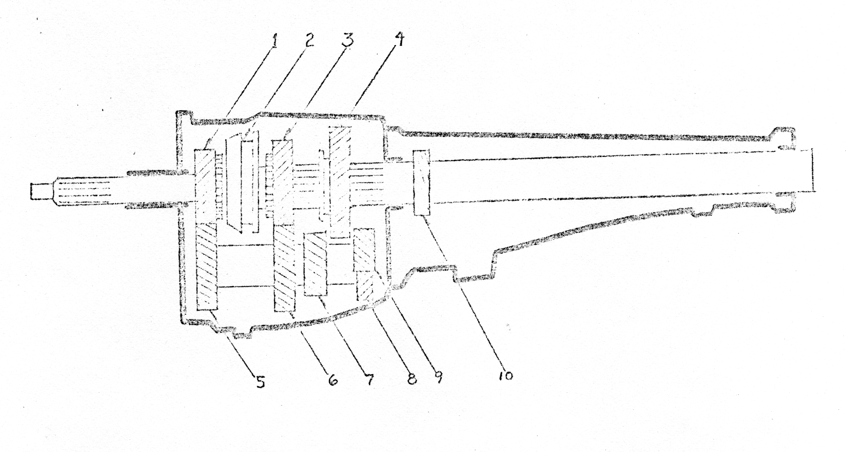
Using the white classroom transmission, locate, identify, and count the number of teeth on the gears.

 | Name of Component | Number of Teeth
1.
2. |  | None
3.
4.
5.
6.
7.
8.
9.
10.
Assignment:

- Give three reasons why a transmission is necessary.
- State in the proper order how the power flows through the transmission while in:

Reverse | Low | Second | High | Neutral

- What are the grooves on the front shaft called that locates the hub of the clutch?
- What is located at the rear of the transmission tail housing to prevent lubricant leakage?
- How much lubricant should a standard transmission have?

Check Point _________

