Mechanics Tools Answers X102a

Learn the names of the tools used in the mechanics trade pictured below - to be used with X102
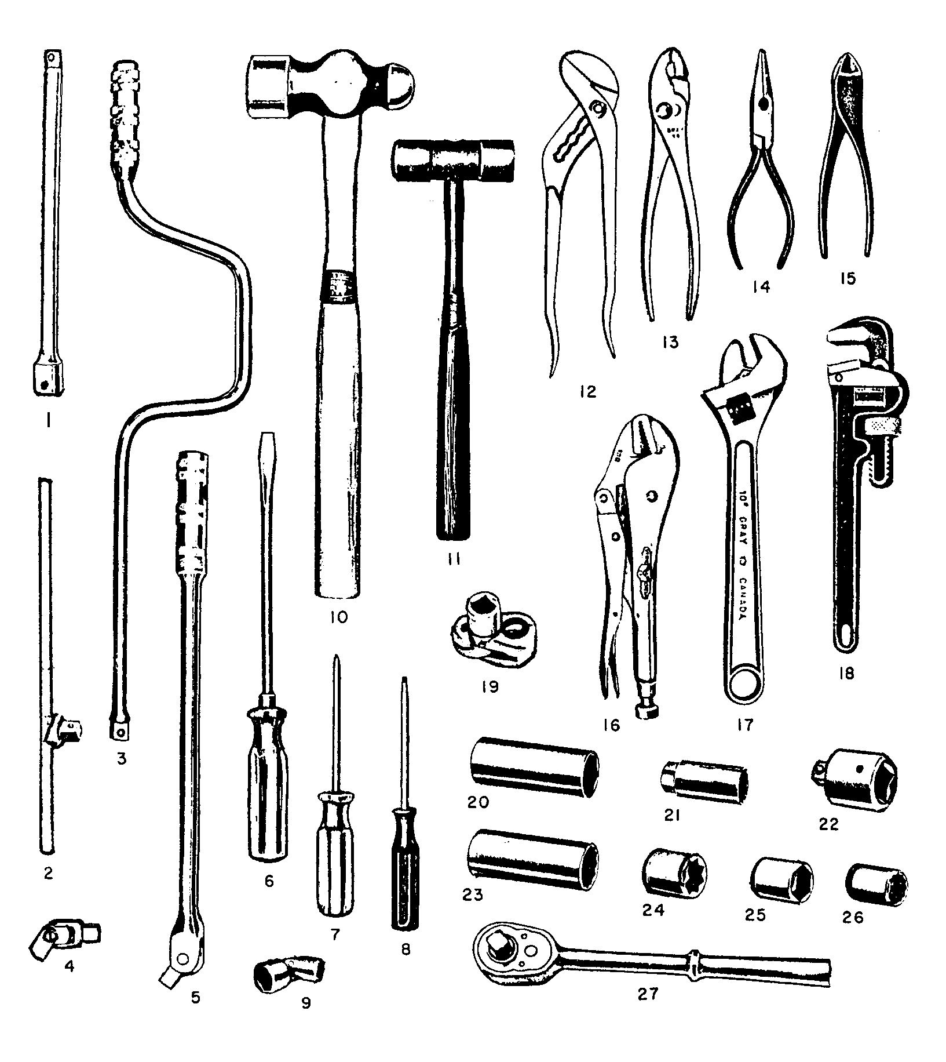
1. Extension Bar
2. Sliding T Handle
3. Speed Wrench/Handle
4. Universal Joint
5. Flex handle/Breaker Bar
6. Flat Blade Screwdriver
7. Phillips Screwdriver
8. Robertson Screwdriver
9. Universal Joint Socket
10. Ball Peen Hammer
11. Soft Face Hammer
12. Water Pump Plier
13. Combination Plier
14. Long Nose/Needle Nose Plier
15. Diagonal Cutting Plier
16. Locking Plier
17. Adjustable Wrench
18. Pipe Wrench
19. Stud Remover
20. Deep Six Point Chrome Socket
21. Spark Plug Socket
22. Adapter
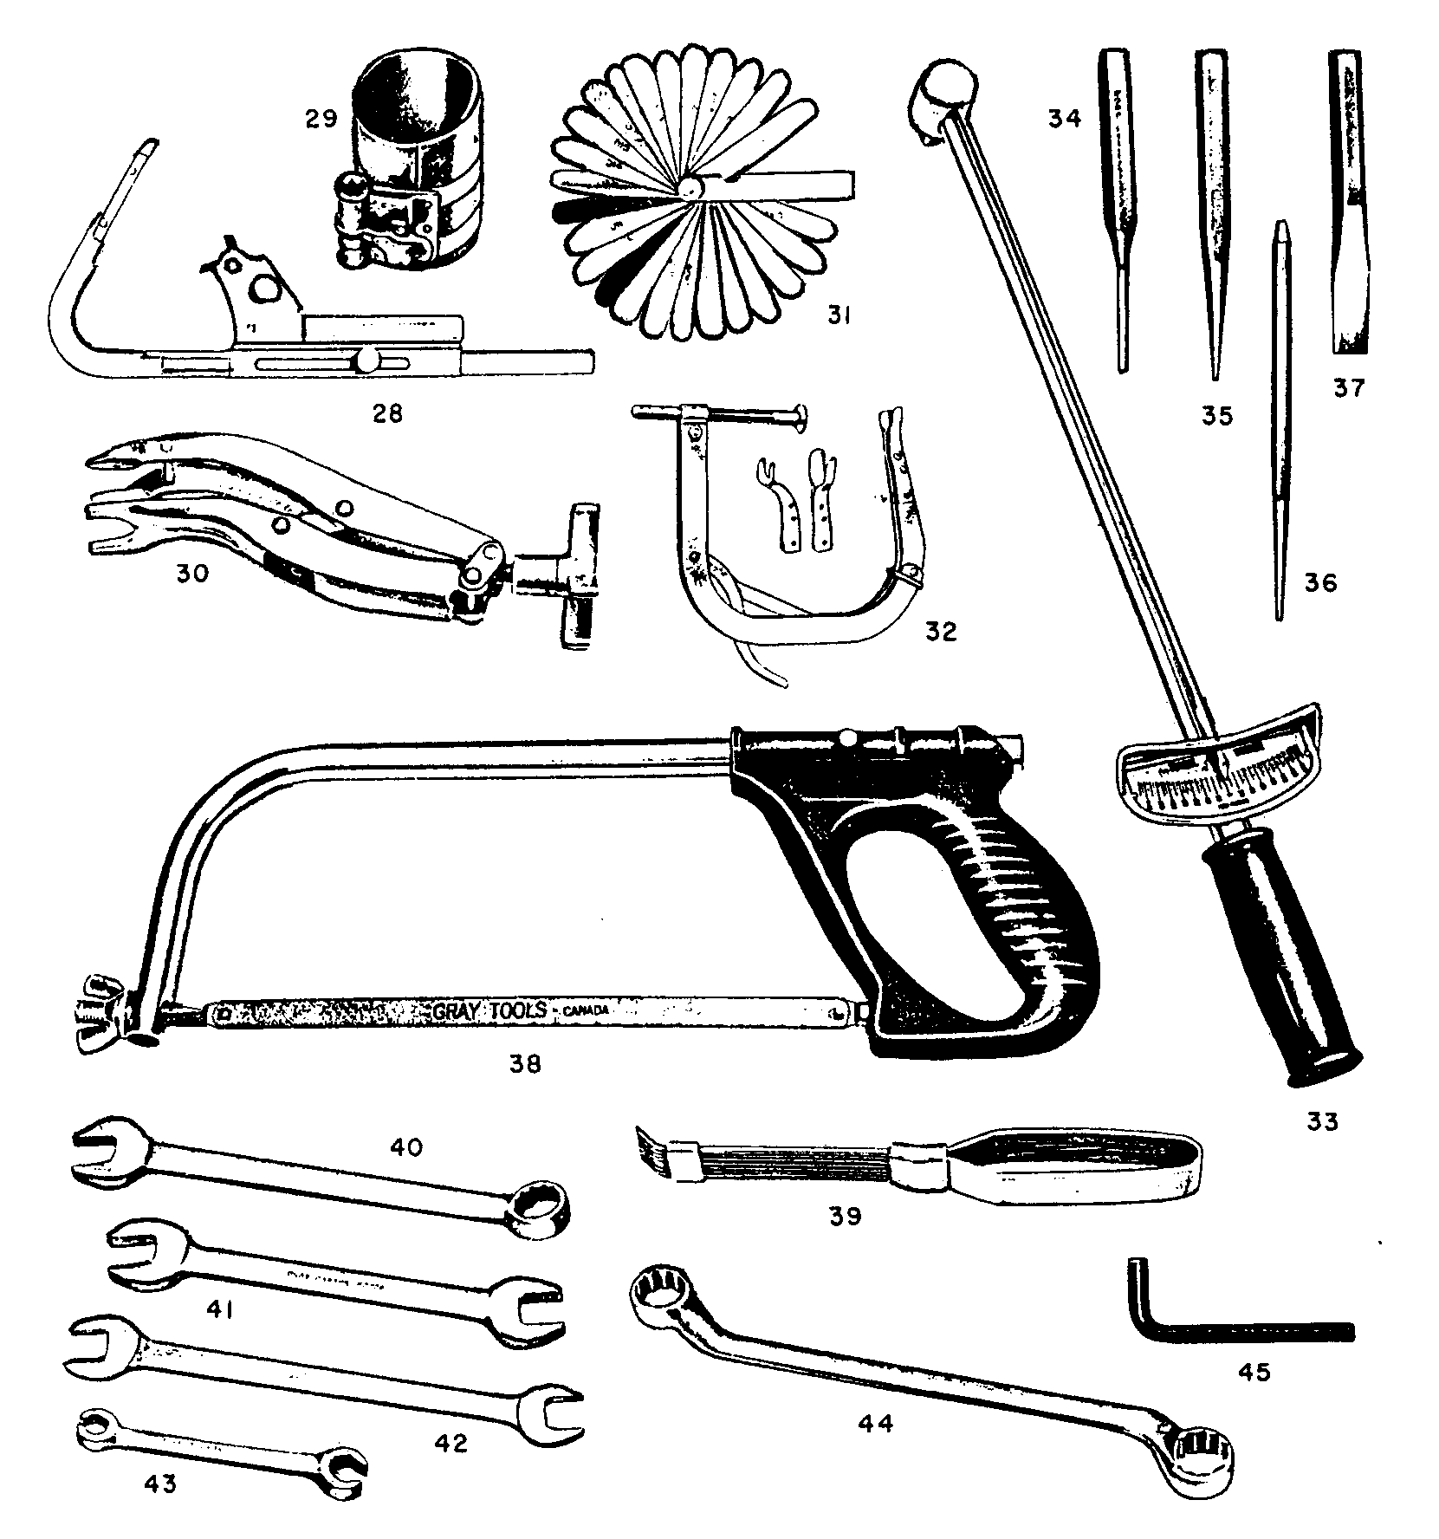
23. Deep Twelve Point Chrome Socket
24. Square Socket
25. Six Point Shallow Chrome Socket
26. Twelve Point Chrome Shallow Socket
27. Ratchet
28. Ring Groove Cleaner
29. Ring Compressor
30. Small Engine Valve Spring Compressor
31. Feeler Gauge
32. Multi Cylinder Valve Spring Compressor
33. Torque Wrench
34. Pin punch
35. Centre punch
36. Long taper punch
37. Cold steel chisel
38. Hack saw
39. Carbon scraper
40. Combination wrench
41. Open end wrench
42. Tappet wrench
43. Flare Nut Wrench
44. Box wrench
45. Allen wrench

